Bhartiyam International School
Pre-Mid Term Assessment (2022 -23)
Subject: Science
Class: X
Date: 14/07/2022 M.M: 40
Name: _________ Roll No.____ Duration: 90 mins
General instructions:-
- This question paper contain four sections.
- SECTION A consist of five questions of 1 mark each.
- SECTION B consist of five questions of 2 mark each.
- SECTION C consist of five questions of 3 mark each.
- SECTION D consist of two questions of 5 mark each.

SECTION – A (1 x 5=5)
1. Write the balanced chemical equation for the following word equation-
Zinc + Silver Nitrate → Zinc nitrate + Silver
2. Explain two ways by which food industries prevent rancidity.
3. What 1 watt power?
4. What is the mode of nutrition in fungi and plasmodium?
5. Which of the four chambers of the human heart has the thickest muscular walls?

SECTION – B (2 x 5=10)
6. How do the guard cells regulate opening and closing of stomatal pores?
7. A student boils water in an electric kettle for 20 minutes. Using the same mains supply he wants to reduce the boiling time of water. To do so should he increases or decrease the length of the heating element? Justify your answer.
8. Why is it necessary to separate oxygenated & deoxygenated blood in mammals & birds?
9. Give one reason why multi cellular organisms require special organs for exchange of gases between their body and their environment.
10. A wire of length L and resistance R is stretched so that its length its doubled. How will its
(a) Resistance change
(b) Resistivity change
SECTION – C (3 x 5=15)
11. How will you indicate the following effects in a chemical equation? Give one example for each-
(a) A solution made in water (b) Exothermic reaction (c) Endothermic reaction

12. a)Which of the following is a combination and which is a displacement reaction?
i) Cl ₂ +2KI→2KCl+I ₂ ii) 2K+Cl₂→2KCl

b) In the following reaction which substance is reduced?
PbS_{(s)} +4H₂O_{2(aq)}→PbSO_{4(s)} +4H₂O _{(l)}

13. Two lamps, one rated 60 W at 220 V and the other 40 W at 220 V, are connected in parallel to the electric supply at 220 V.
(a) Calculate the current drawn from the electric supply.
(b) Calculate the total energy consumed by the two lamps together when they operate for one hour.
14. In the above circuit, if the current reading in the ammeter A is 2A, what would be the value of R1?
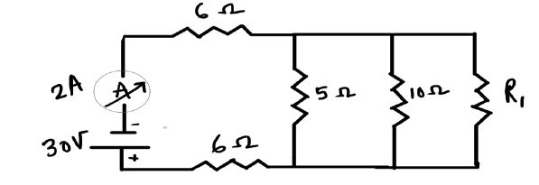
15. What are different ways in which glucose is oxidized to provide energy in various organisms?
SECTION – D (5 x 2=10)
16. Describe the structure and functioning of nephron.
17. a) You might have noted that when copper powder is heated in a china dish, the surface of copper powder becomes coated with a black colour substance.
(i) How has this black coloured substance formed?
(ii) What is that black substance?
(iii) Write the chemical equation of the reaction that takes place.
b) Why does the colour of copper sulphate solution change when an iron nail is dipped in it? Write two observations.

